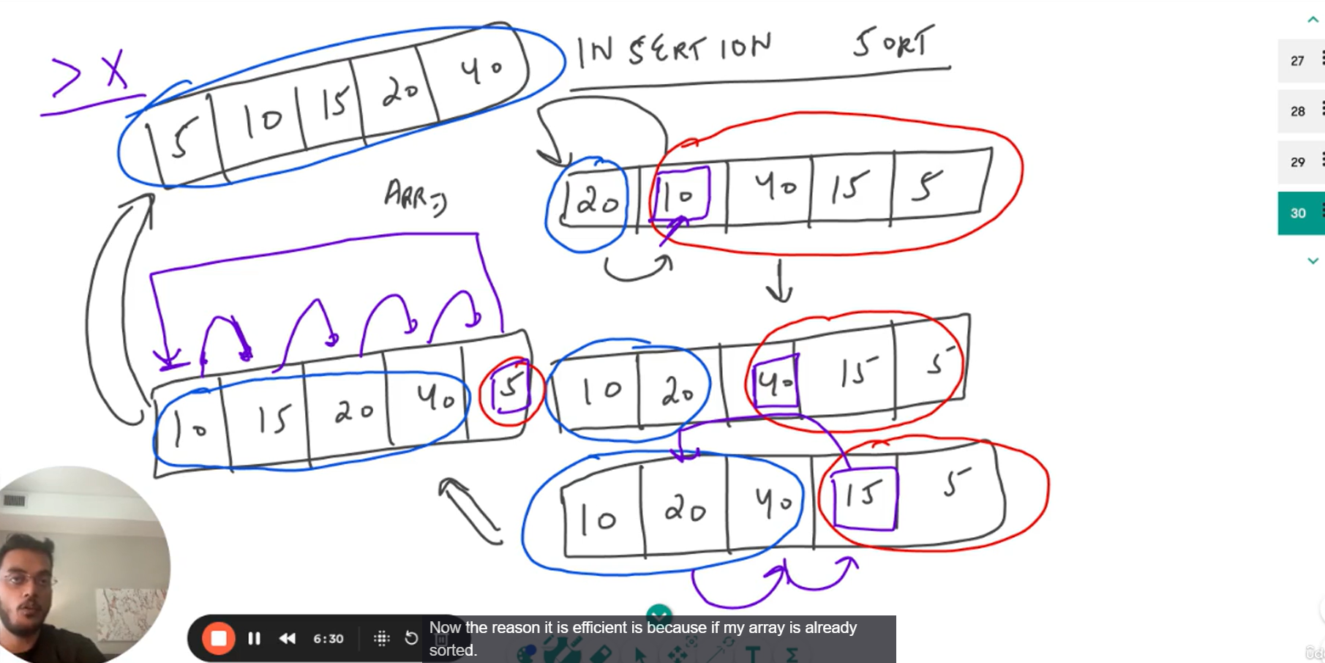
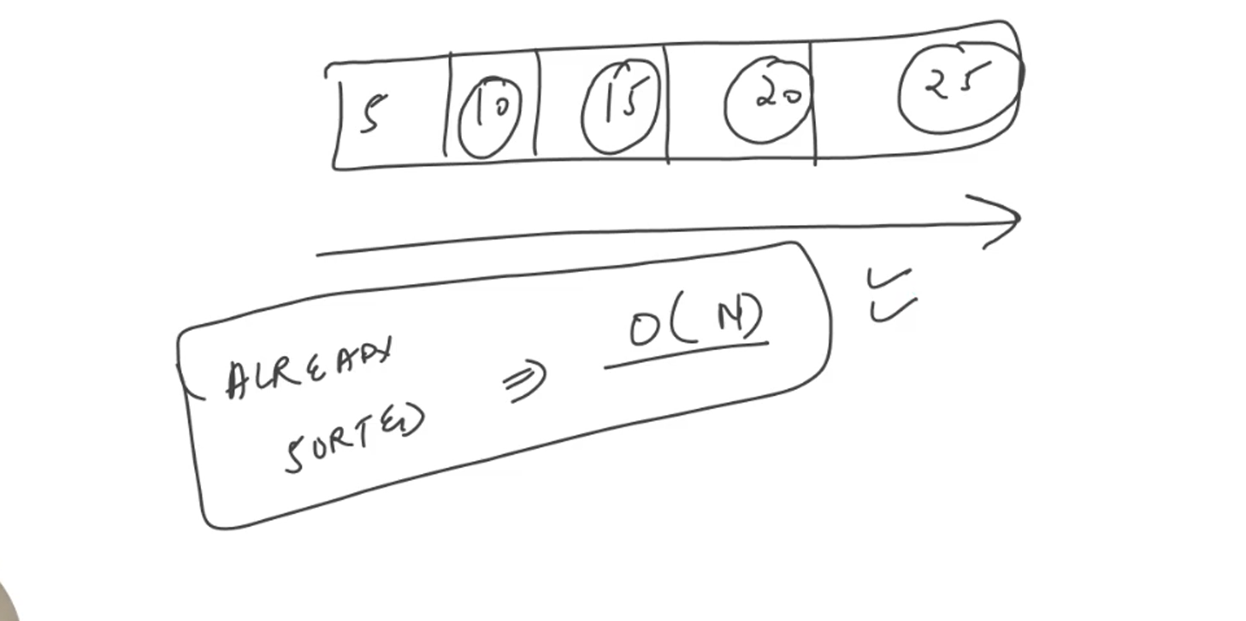

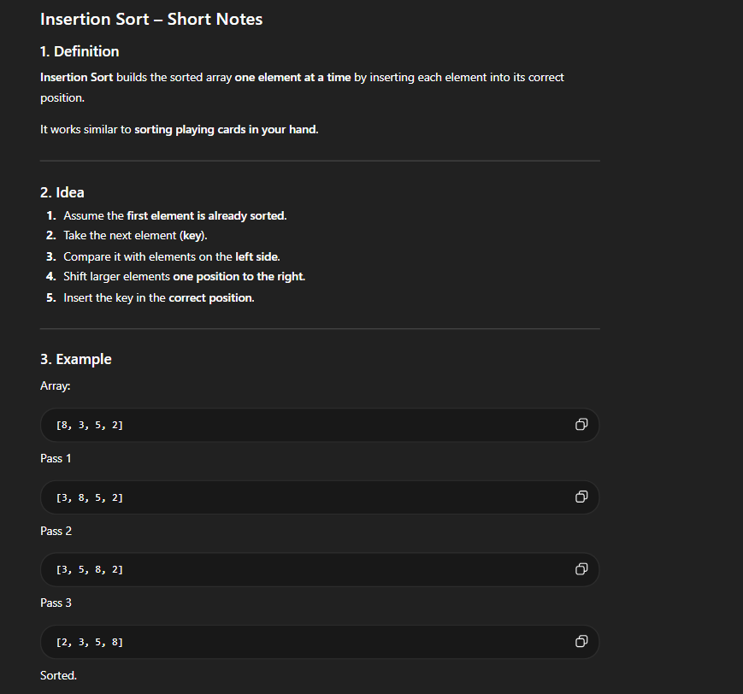

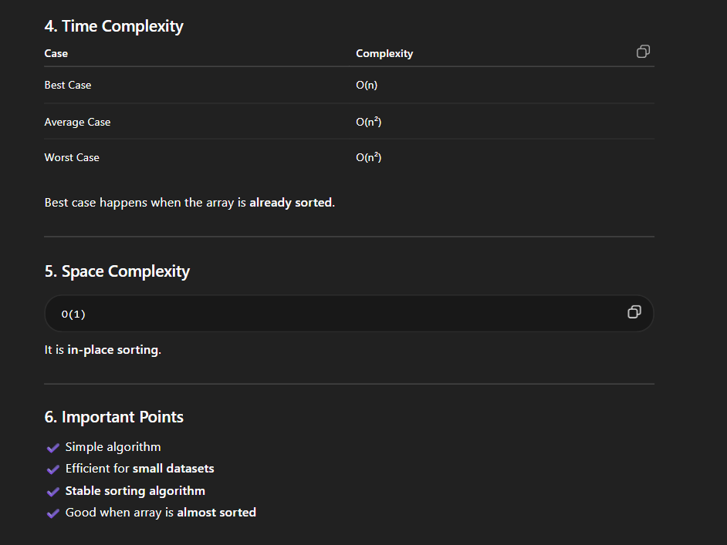

SO WE KEEP ON ITERATING FROM I=1 AND FOR EACH VALUE WE COMPARE WITH PREVIOUS VALUE TO CHECK WHEHER THE PREVIOUS IS GRATER THAN THE KEY IF YES THEN WE MOVE THAT PREVIOUS ELEMENT TO THE RIGHT

arr[j+1]=key; this line j+1 because at the end j becomes 0 at index 0 the condition is fale which mean the key should be placed next to that index eg if we want to put key 6 and the array is 5 10 6 …we put 6 after 5 not on 5;

